**Mongo First Time Setup:**

1. **Startup Mongo Database:**

Navigate to the root directory of the MongoDB.

* cd c:\Program Files\MongoDB 2.6 Standard\bin
* run the command : mongod --dbpath="C:\iGo\MongoDB"

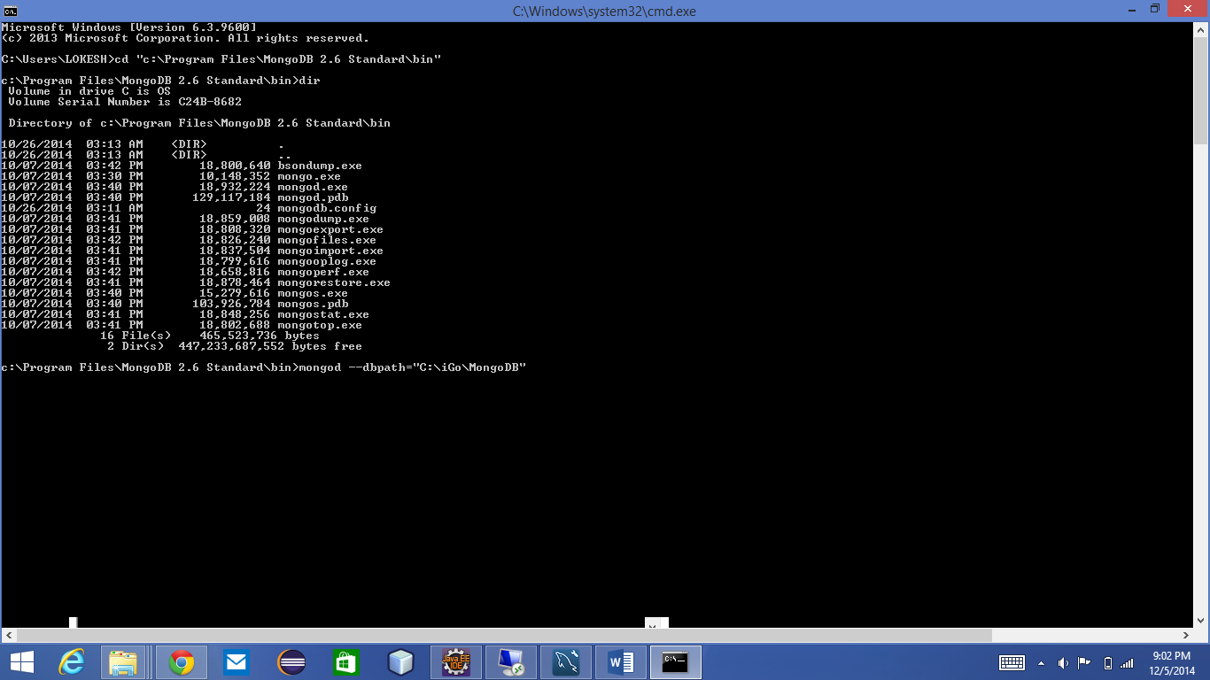

1. Use MongoDB

Navigate to the root directory of the MongoDB.

* cd c:\Program Files\MongoDB 2.6 Standard\bin
* run below commands :



* mongo
* use iGo
* db.adduser({user:"root",pwd:"cs441",roles:["readWrite"]});

Note:

* Presently iGo project is configured to run on a default port “27017”
* Unless the user is create the mongodb connection can not be established
* All the collections will be automatically created
* Seamless transmission of data from the FrontEnd & JAX-WS WebService will be loaded to MongoDB & mySQL database.

http://54.69.206.155:8080/HappyFront/

http://54.69.0.233:8080/iGoWeb/HappyPathClientService?Tester